Easy Pass Documentation



Table of Contents

1. Introduction/Technology………………….……………………………………………............................pg-3
2. Prototype Access Information…………………………………………………………........................pg-4 to 5
3. Customer Business Process Model (BPM)………......................................................................................pg-6
4. Clerk or Customer Service Rep Business Process Model (BPM)…………………………………………pg-7
5. Work Breakdown Structure (WBS)………………………………………………………………………..pg-8
6. Functional Decomposition Diagram (FDD)…………………………………………………………….....pg-9
7. Required System Output Examples…………………………………………………………..……...pg-10 to 17
8. Use Case Diagram and Use Case Description……………………………………………………….pg-18 to 19
9. Entity Relationship Diagram (ERD)………….……………………………………………….…………..pg-20
10. User Documentation…………………………………………………………………………..…….pg-21 to 22

Introduction

This system is built using a powerful tool created by Microsoft name as Access. Access is a database management system which incorporates graphical user interface to manage different information and is also powered by software-development tool like visual basic.

In order to build this Easy Pass system, I choose access is because I can create user friendly forms for the client to enter their information and also for the manager and clerks to maintain those data and make report using powerful tools included in the access.

Prototype Access Information

1. **To use this system (Create new user), follow the following instructions:**
2. Unzip the file named Easy Pass final.zip
3. After unzipping the file open the application named Easy Pass.accdb.
4. To get started, first click the link “Login Form” under the heading “Forms” on the left pane named “All access obj…”
5. New login window will open up, if you are new user click the link labeled “New User?? Sign-up here”.(**to log as existing user in follow the instructions on page 5**)
6. Enter the asked information (On the table under ‘Vehicle Information’ input your information on the table where the data are not yet filled and select the highest maximum number in the ‘Customer ID’ field).
7. Click save with all the information filled in and close the window.
8. Go back to “Login Form” window and login to the system with the information you have saved in the system.
9. **Access the current user profile (The credentials are case sensitive)**
10. Follow the step from 1. a to c on page 4 to open the application, and use the provided credentials below to login to an existing account.
11. For Customer:

|  |  |
| --- | --- |
| **LoginID** | **Password** |
| Manjil | itani |
| Justin | biber |

1. For Clerk (Account Manager/ Customer Service Rep):

|  |  |
| --- | --- |
| LoginId | Password |
| Wendy | Gilire |

Customer Business Process Model (BPM)

**Creating a user account:**

Process

Fill in the personal information

Process

Fill in the vehicle information.

Process

Verify all the information are within the criteria.

Clerk or Customer Service Rep Business Process Model (BPM)

**Assigning Easy Pass tags to the customer:**

Process

Find the customer to assign tag to.

Process

Find an available tag.

Process

Change the status of both the customer and tag assigned

|  |  |  |  |  |
| --- | --- | --- | --- | --- |
| **Work Breakdown Structure**  **(Toll Management & Account Replenishment Prototype Development)** | | | | |
| Task number | Description | Duration (Hours) | Predecessor Tasks | Completed |
|  | Create a table to store toll location data | 25 mins |  | Yes |
|  | Design a form to input information to toll location table | 35 min | 1 | Yes |
|  | Collect price information for the respective toll location from internet | 1 hour |  | Yes |
|  | Test system by adding the information gathered from the MTA | 20 mins | 2,3 | Yes |
|  | Create a report based on the information gathered on the toll location table | 35 mins | 1 | Yes |

#4 is the milestone because this step verifies that the function to add toll information is working smoothly in the system

Functional Decomposition Diagram (FDD)

Required System Output Examples

1. Tag list
2. Output name- Tag list report
3. Report recipient- Inventory manager
4. Report Sort order- Ascending order by Tag ID

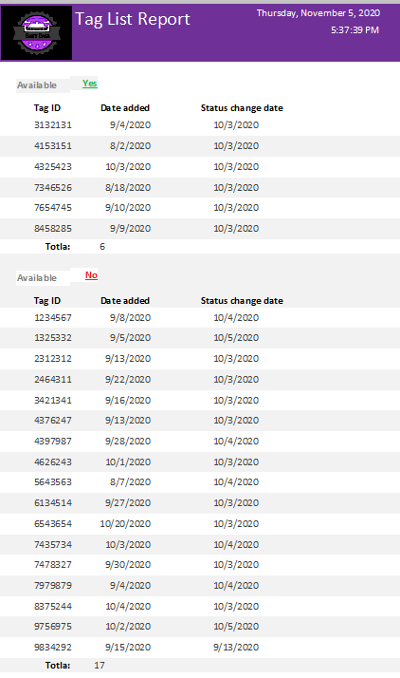

1. Customer Account list
2. Output name- Customer account list report
3. Report recipient- Customer Service Manager
4. Report Sort order- Ascending order by full name

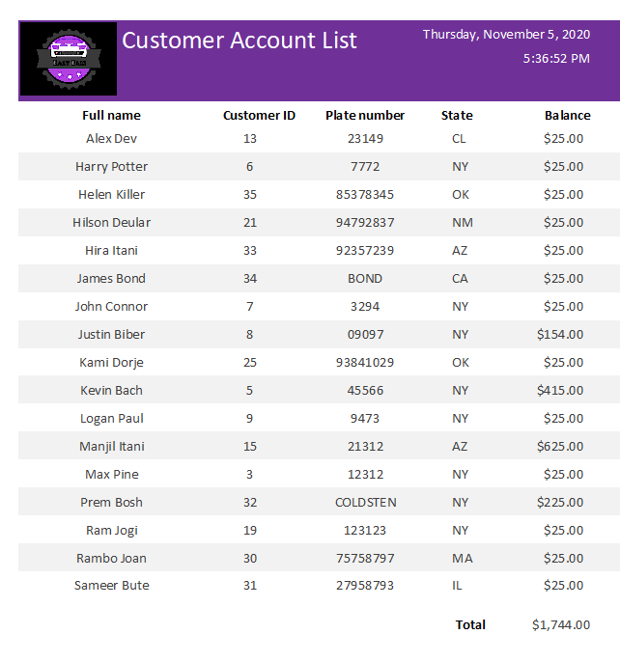

1. Customer Tag List Report
2. Output name- Customer tag list report
3. Report recipient- Customer Service Manager
4. Report Sort order- Ascending order by full name

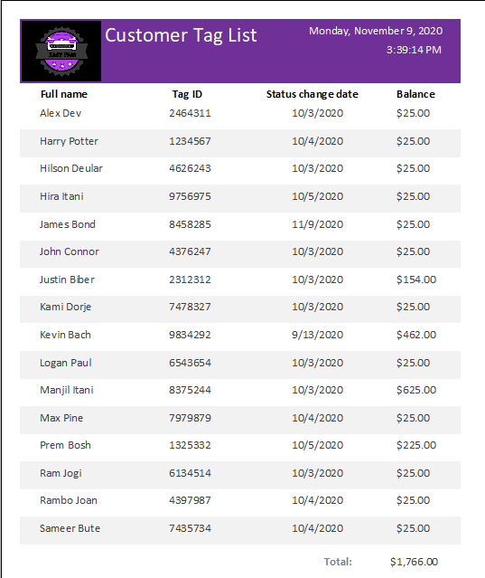

1. Toll List Report
2. Output name- Toll list report
3. Report recipient- Toll Operations Manager
4. Report Sort order- Ascending order by toll location name

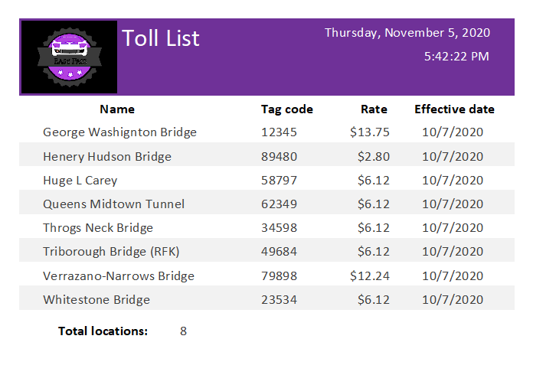

1. Customer Account Refill Receipt
2. Output name- Customer account refill receipt
3. Report recipient- Customer (Kevin Bach)
4. Report Sort order- Not Applicable

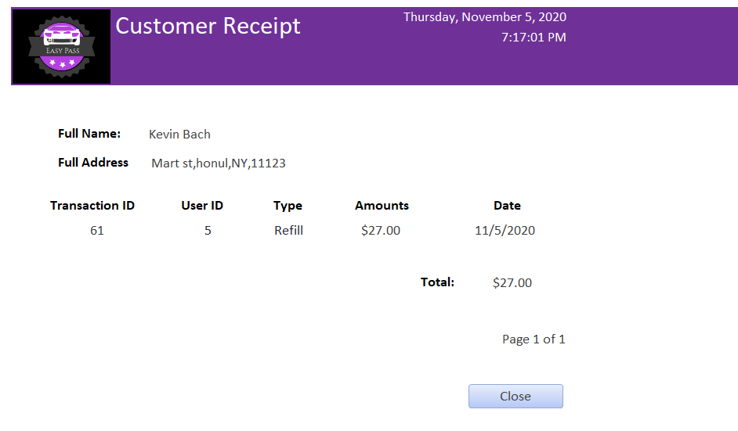

1. Account Activity List Report
2. Output name- Activity list report
3. Report recipient- Accounting Manager
4. Report Sort order- Ascending order by date of transaction

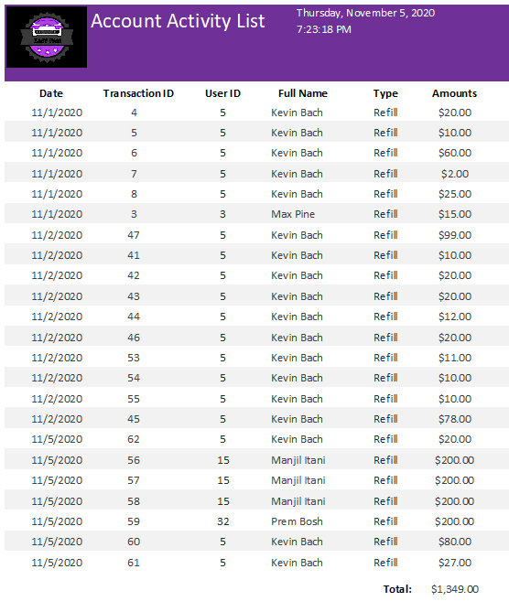

1. Revenue by Customer Report
2. Output name- Revenue by Customer Report
3. Report recipient- Accounting Manager
4. Report Sort order- Ascending order by Full name

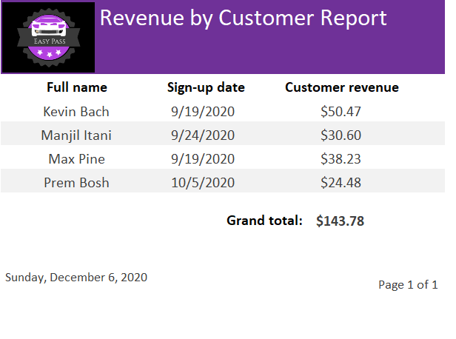

1. Revenue by Toll Report
2. Output name- Revenue by Toll Report
3. Report recipient- Accounting Manager
4. Report Sort order- Ascending order by Toll name

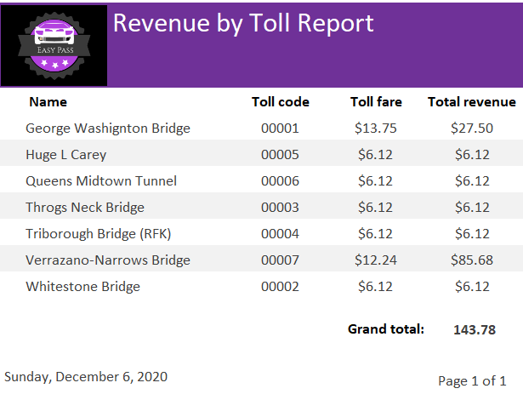

Use Case Diagram and Use Case Description

Use case diagram: -

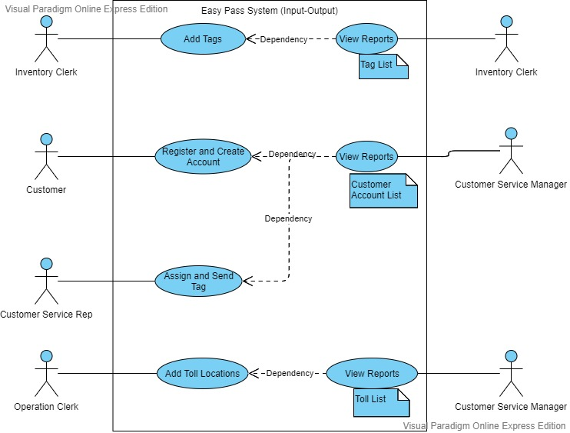

Use case description: -

|  |  |
| --- | --- |
| Assign Tags  (Assign and Send Tag use case) |  |
| Name: | Assign and Send Tag |
| Actor: | Customer Service Representative |
| Description: | This use case allows customer service representative to assign tags to the customers who does not have a tag assigned already. |
| Successful completion: | 1. The customers can see tag number instead of “N/A” when they login to their account. 2. The assigned customer is reported and listed in the ‘Customer Tag List’ report. 3. Customers are now able to through their account make trips. |
| Precondition: | Tags are added to the system by inventory clerk so that they can be assigned to the customers in the future. |
| Postcondition: | Customer must be able see tag number in the ‘Tag ID’ field once they login.  Customer must be able to see the added customer detail in the ‘Customer Tag List’ report. |
| Assumptions: | None |

Entity Relationship Diagram (ERD)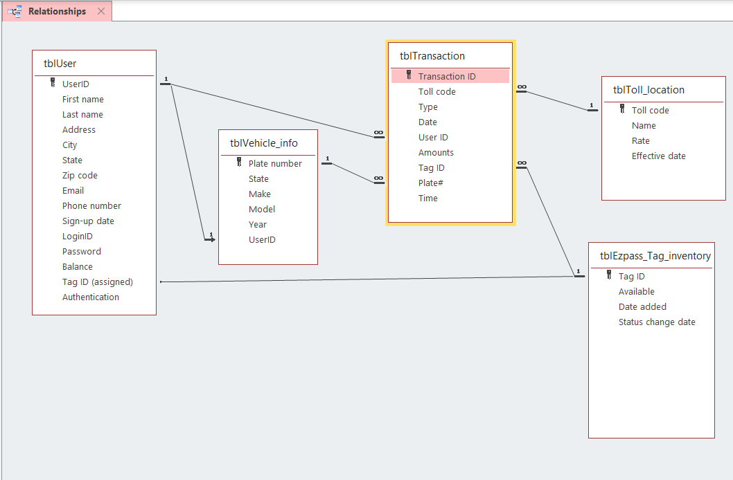

User Documentation

1. **Customer Documentation (**If needed, use the credentials in page 5 to login and perform these actions)**:**

1. **To create a new account:** Upon opening the ‘Login Form’, click on ‘New User?? Sign-up here’ link and fill up all the required personal and vehicle information’s and click ‘Save’ and now you can go back to the ‘Login Form’ window and enter the created credentials to login to your account.
2. **To add balance:** Once Logged in click on the ‘Manage Funds’ tab to and click ‘Add Balance’, on the next window that pops-up enter the amount you would like to add to your current balance in the field ‘Amounts’ and click ‘Add funds’. Done!
3. **To make a trip:** (\**Alert: You must be assigned a tag before you can make a trip)* On the top right of your account (after logged in) click ‘Make a trip’ to make a trip and on the following window select the location you want to make a trip to and click ‘Make a trip’ to make a trip.
4. **To see statement:** Click on ‘View statement’ on the top left of the customer’s account to see the statement.
5. **Employee Documentation (**If needed, Use the credentials in page 5 to login and perform these actions**):**

*All the employees can access their functions under the ‘Clerks’ form, all the reports can be seen under the ‘Reports’ tab after the employee’s login.

1. **To add tags (Clerk):** Once logged in click on ‘Create New Tag’ under ‘Tag functions’ and enter required information’s on all the field to create a new tag and click ‘Save’.
2. **To assign tag (Customer service representative):** Once logged in click on ‘Assign Tag’ under ‘Tag functions’ and click ‘Next record’ until you see ‘N/A’ in ‘Assign Tag’ field, once found the customer without a tag or with ‘Assign Tag’ field as ‘N/A’ click the drop down on ‘Assign Tag’ field and choose the tag with ‘Yes’ status which indicates the tag is not assigned yet and click the Available box under ‘Tag inventory change’ to assign tag to the customer.
3. **To add toll location:** Once logged in click on ‘Add/Update Toll Locations’ under ‘Tag functions’ and enter the location and the price you would like to add along with other field to add the toll location to the system so that customers can uses the toll location. Click ‘Save’ to save the location information’s.